PROJECT MANAGEMENT
ANSWERS TO QUESTIONS
NAME : Manuel Kevin ZE FOUDA

- Problem to solve
Implementing a full information system security plan: auditing existing vulnerabilities, deploying MFA and EDR/Antivirus solutions, and strengthening the overall cybersecurity posture of the organization.
- Constraints
Strong sequential dependencies between tasks.
- Impact
Stakeholder | Expectations
MOA, MOE | Budget approval, closure report, risk reduction
IT Administrators | Training, technical documentation
End Users | Cybersecurity awareness, adaptation to new tools
Project Manager | On-time and on-budget delivery

- What events could cause the project to fail?
- Refusal or delay of budget approval
- Late delivery of MFA or EDR licenses
- Discovery of major vulnerabilities during testing requiring lengthy fixes
- Unavailability of administrators for training sessions

- Success criteria
- Closure meeting held
- Technical documentation delivered
- Security tests validated with no blocking anomaly
- MFA and EDR fully deployed and operational

- Duration : 36 Days

- End of the project : 24 November 2025

- Tasks belonging to the critical path

TASKS
Lancement du projet
Analyse de l’existant SI
Audit cybersécurité initial
Identification des vulnérabilités
Définition du plan de sécurisation
Validation budget direction
Achat licences MFA
Achat solution EDR/Antivirus
Déploiement MFA
Déploiement solution EDR
Tests de sécurité et validation
Corrections anomalies
Documentation technique
Formation administrateurs IT

- Regroup tasks
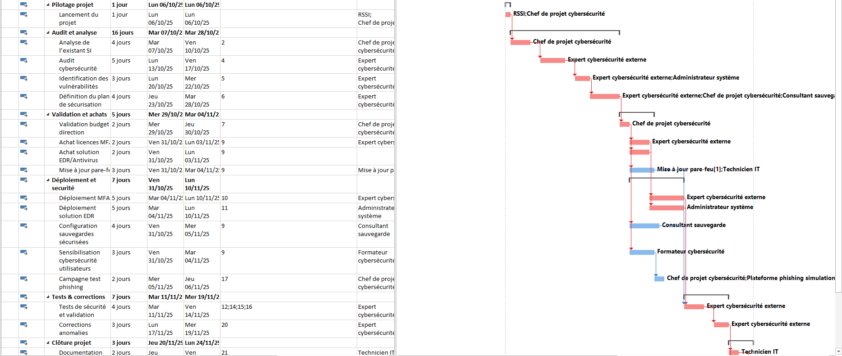

- Which activities can be carried out simultaneously to optimize the schedule?
The 4 non-critical tasks can run in parallel with critical tasks :
- Firewall update
- Secure backup configuration
- User cybersecurity awareness
- Phishing test campaign
These tasks carry float and do not extend the overall duration if properly scheduled.
- If the CEO requires a 20% schedule reduction, what do you propose?
New end date: 36 days – 20% equals to 29 working days. So the new end date will be on November 13, 2025.
My proposals:
- Anticipate license orders before formal budget sign-off (conditional purchase order)
- Compress Initial cybersecurity audit from 5d to 3d by assigning a two-person audit team
- Compress MFA/EDR deployments from 5d to 3d with a reinforced deployment team;
- Merge documentation and training simultaneously over 2 days instead of sequentially

- GANTT Diagram:

- Project statistics:
